Polyphenols and Antioxidant Activity
of selected
Austrian Wines and Grape Juice

Gerhard Kroyer
Institute of Chemical Engineering
Division of Natural Substances and Food Chemistry
University of Technology Vienna, Austria
INTRODUCTION

There is a growing interest in the food industry and in preventive health care in the development of natural antioxidants from plant materials. Consumption of a diet rich in antioxidant active polyphenol compounds has been linked with a beneficial health impact. Products from viniculture such as grapes, grape seeds, grape juice and wine are rich in polyphenol compounds which are considered as bioactive and antioxidant active substances and have been linked to beneficial and preventive effects toward several chronic diseases.
The objective of this study was todetermine the content of total polyphenol compounds and of proanthocyanidins in selected red and white wine varieties cultivated in Austria and to evaluate their antioxidant activity and radical scavenging ability which is suggested to be responsible for their positive health benefits.

MATERIALS and METHODS

Grape juice and wine of different red and white Austrian grown grape varieties:
- Red wine: “Zweigelt”, “Blaufränkisch”, “Syrah”, “Cuvee (Cabernet Sauvignon, Merlot, Zweigelt, Blaufränkisch)”
- White varieties: „Chardonnay“, „Pinot Blanc“
- White & red grape juice

- Total polyphenols: Folin-Ciocalteu method
- Proanthocyanidins: photometric analysis after acid depolymerisation to the corresponding anthocyanidins
- Antioxidant and radical scavenging capacity:
DPPH radical scavenging method in terms of their
Efficient Concentration EC₅₀ (ml wine/mg DPPH) and their
Trolox Equivalent Antioxidant Capacity TEAC (mMol Trolox/l)
RESULTS and DISCUSSION

- Above all the red wine varieties showed remarkable amounts of total polyphenols (1594 – 2211 mg/l) and proanthocyanidins (70 – 86 mg/l) compared to white wine (278 & 334 mg/l, respectively 0,7 & 1,1 mg/l) and grape juice (110 & 710 mg/l, respectively 6,9 & 11,6 mg/l; more pronounced in red grape juice).

- Correlating with the total polyphenol content, the highest antioxidant and radical scavenging capacity was observed in the red wine samples (EC₅₀: 0,21 – 0,30; TEAC: 2,5 – 3,6 ) compared to the white wine varieties (EC₅₀: 2,74 & 3,30; TEAC: 0,23 & 0,28) and grape juice (EC₅₀: 15,02 & 1,34; TEAC: 0,05 & 0,72; more pronounced in red grape juice).

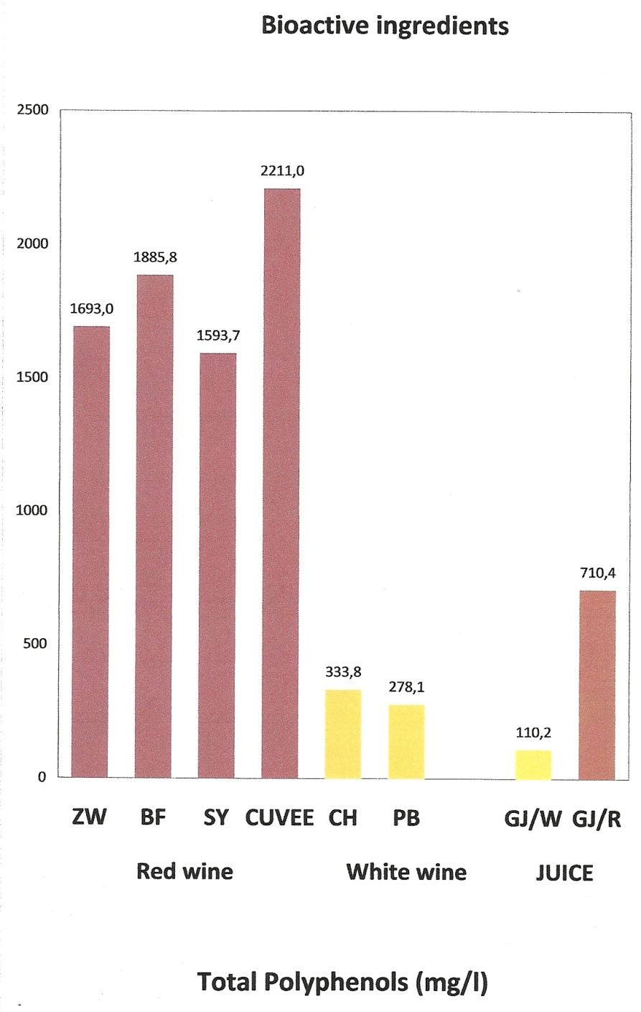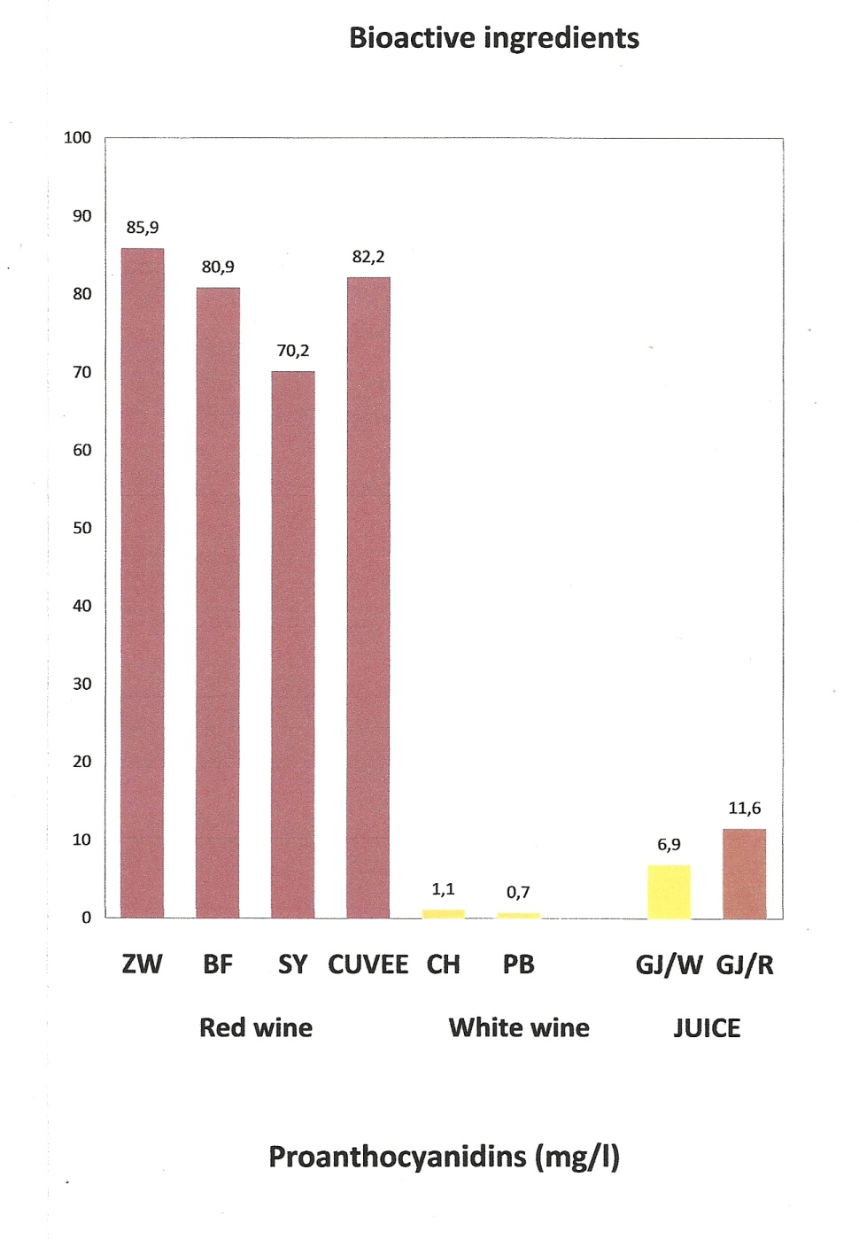

Wine / grape juice | EC50  (ml/mg DPPH) | TE  (mMol Trolox/l)
ZW | 0,28 | 2,7
BF | 0,29 | 2,6
SY | 0,30 | 2,5
Cuvee | 0,21 | 3,6
CH | 2,74 | 0,28
PB | 3,30 | 0,23
GJ/W | 15,02 | 0,05
GJ/R | 1,34 | 0,57

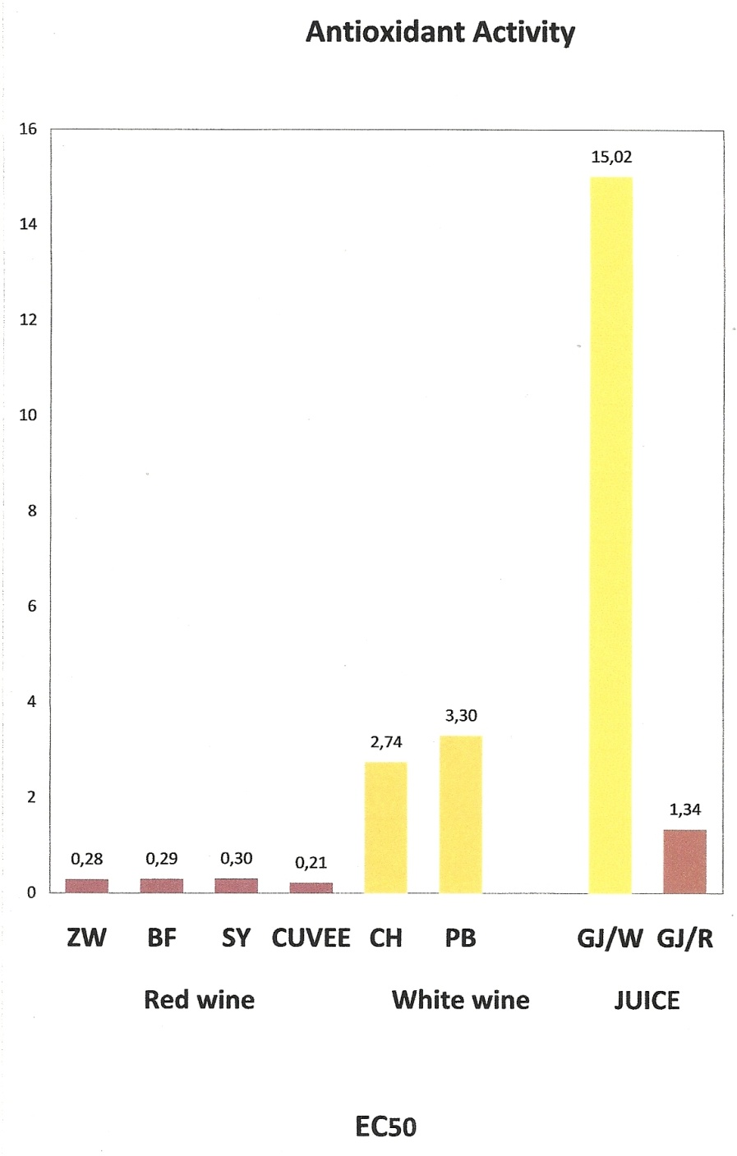

CONCLUSION

- Above all the red wine varieties showed remarkable amounts of total polyphenols and proanthocyanidins compared to white wine and grape juices.
- Correlating with the total polyphenol content, the highest antioxidant and radical scavenging capacity was observed in red wine.
- Red grape juice exerted as expected minor radical scavenging capacity than red wine but was more pronounced than white wine. White wine juice showed relatively poor antioxidant effectiveness.

Moderate consumption wine especially red wine
offer a potential beneficial impact in maintaining and promoting health
due to their remarkable content of polyphenols and proanthocyanidins
as bioactive substances and their high radical scavenging capacity.

