SIMULATION OF ACTUAL NETWORK PERFORMANCE USING KRONECKER ALGEBRA FOR OPTIMIZATION OF TRAFFIC FLOW
Andreas Schöbelª, , Jelena Aksentijevićª, Daniel Hürlimann^{b}
a OpenTrack Railway Technology GmbH, Kaasgrabengasse 19/8, Vienna 1190, Austria, andreas.schoebel@opentrack.at jelena.aksentijevic@opentrack.at
b OpenTrack Railway Technology GmbH, Gubelstraße 28, Zurich 8050, Switzerland, huerlimann@opentrack.ch

Abstract: Within the project GoSAFE RAIL, one work package is dedicated to the development of an integrated rail network model that will incorporate both infrastructure asset (e.g. crossings, tracks, bridges, tunnels) and traffic (e.g. vehicle, freight and passenger movement) data with the main goal of offering safer, reliable and efficient rail infrastructure. This will be achieved by using the micro-level simulation tool OpenTrack for enabling capacity optimization in order to maximize the availability of the transport network and minimize environmental impacts. Up to now, optimization was typically predefined by the user of the tool and ‘tested’ for its applicability, which led to missed opportunities for finding an optimal solution. This modelling tool will be able to dynamically optimise operations, in particular during times of degraded operations using multi-criteria optimization algorithms in order to address complex requirements, for both passenger and freight transport. By employing Kronecker algebra for optimization and software’s application programming interface (API) in the case study network Zagreb – Rijeka in Croatia, the behavior of actual network performance will be simulated as a proof of suitability of solutions provided by the optimization algorithm. Finally, an expected impact of the advanced traffic model using scheduling algorithm is a 40% reduction of delays in long-distance traffic.
Key words: micro-simulation, rail operations, traffic flow model, infrastructure maintenance, optimization algorithm

INTRODUCTION
Rail infrastructure managers are responsible for safety measures and planning within the infrastructure network. Although the railway transport mode is considered one of the safest modes of transport (European Railway Agency, 2013) with 0.16 fatalities per billion passenger km’s there is a number of infrastructure failures that have happened in recent years. Unfortunately, the number is expected to rise in the future, mainly due to ageing railway network and stronger climate changes. Consequently, the objective of the Shift2Rail project Global SAFEty Management Framework for RAIL Operations (GoSAFE Rail project) is development of an evolutionary Decision Support Tool with the main goal of offering safer, reliable and efficient rail infrastructure.
Application of microscopic simulation of railway operations based upon a physical and mathematical model of the railway system is the state of the art in railway traffic operations. Normally, such tools output indicators for the operational performance, like for example, delays or energy consumption. Up to now, optimization was typically predefined by the user of the tool, introduced into the simulation and ‘tested’ for its applicability during the simulation. This led to missed opportunities for finding an optimal solution, which led to the simulation programs not being able to solve dispatching questions or handle headway conflicts. Simulation tools have, however, one shortcoming; namely, the inability to optimize train ran automatically. To close this gap within railway operations with increased traffic, algorithms which consider all train runs at the same time have been developed and applied. Using Kronecker algebra, microscopic simulation tool will both improve traffic flow and assess the impact of maintenance and renewal proposals, as part of support for decision making of the infrastructure manager. The algorithm for calculating the optimal driving strategy and optimizing the overall railway system is based on the PhD-thesis “Energy-efficient Optimization of Railway Operation. An Algorithm Based on Kronecker Algebra” by Volcic (2014).
Moreover, with OpenTrack micro-simulation modelling tool, traffic model will be developed that will use multi-criteria optimization algorithms to address complex requirements, for both passenger and freight transport. Using Kronecker algebra (Mittermayr et al., 2012) which showed good results in dealing with optimization scenarios in railway traffic flow, especially avoidance of bottlenecks and conflicts, simulation of actual network performance on the line between Zagreb and Rijeka in Croatia will be performed.
The input data used for the traffic flow optimization tool is defined by two components: first, the current characteristics of the rail system will be supplied, the set of infrastructure, rolling stock and timetable characteristics, which represent the base for future calculations. Secondly, infrastructure manager’s identification and assessment of restricted availability of infrastructure assets. Those two components will be merged using simulation tool OpenTrack (OpenTrack Railway Technology) for the visualization of all existing data, and further processed into the concrete syntax for the input files needed by the optimization tool. This paper deals with the import data necessary for the future optimization calculations.

Motivation for simulation
The main motivation behind dynamic rescheduling is avoidance of unnecessary and time consuming stops. Namely, enabling adaption of driving behavior to constantly changing environment will bring avoidance of bottlenecks and hence, lower delays and consequently, increase capacity (Luethi, 2009). Dataflow in simulation of railway operation with today’s production and operation with integrated real-time rescheduling is presented in Figure 1.
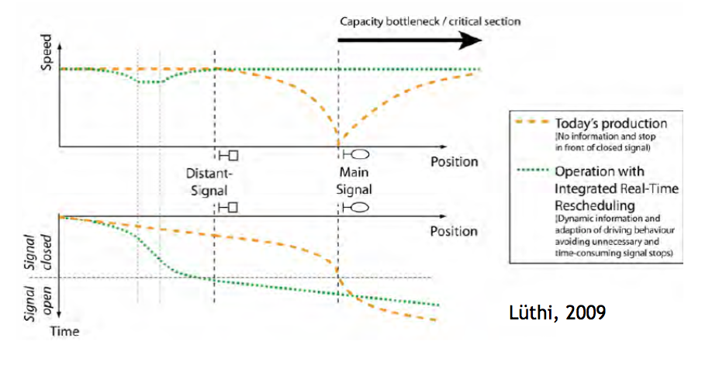
Figure 1. Operational performance without and with real-time rescheduling
The first step in using computer models in the railroad planning is to calibrate the base case model. This should accurately replicate observed railroad operations with the existing infrastructure, rolling stock, and schedules. Once the model has been calibrated it can be used to investigate many issues including estimating the stability of new timetables, determining the minimum infrastructure requirements for a given timetable, or evaluating the impact of rolling stock changes. A significant benefit of models is their ability to evaluate the impact of incidents or time-based network changes (e.g. maintenance) on railroad operations.
Computer simulation is especially valuable for railroad planning since, once developed and calibrated, models can be used for the comparison of the benefits, impacts, and costs of various different improvement packages. To analyze more than a few improvement packages by hand would be prohibitively time consuming. Thus, effective railroad simulation models enable planners to identify and evaluate more alternatives, ultimately leading to more creative and comprehensive problem solutions.
While computer simulation is an excellent tool for analysis and planning of railroads, railroad network simulation programs have the following limitations:
• Programs must be validated to actual conditions.
• Yard operations must be modelled separately.
• Resource constraints such as crew scheduling are largely ignored (although some specialized software does address resource constraints).
• Simulations only include the modelled study area.
• Simplifying assumptions generally create an inherent optimism about overall congestion, schedule adherence, and recoverability (Gibson, 2002).
Given these limitations, especially the last one, it is critical that all simulation results be carefully reviewed, discussed and compared to reality.

Opentrack railway simulation software
OpenTrack was developed at the Swiss Federal Institute of Technology’s Institute for Transportation Planning and Systems (ETH IVT). The project’s goal was development of a user-friendly railroad simulation program that could run on different computer platforms and could answer many different questions about railway operations (Huerlimann, 2001). Figure 2 illustrates the three main elements of OpenTrack: data input, simulation, and output.
OpenTrack is a microscopic synchronous railroad simulation model. As such it simulates the behavior of all railway elements (infrastructure network, rolling stock, and timetable), as well as all processes between them. It can be easily used for many different types of projects, including testing the stability of a new timetable, evaluating the benefits of different long-term infrastructure improvement programs, and analyzing the impacts of different rolling stock.

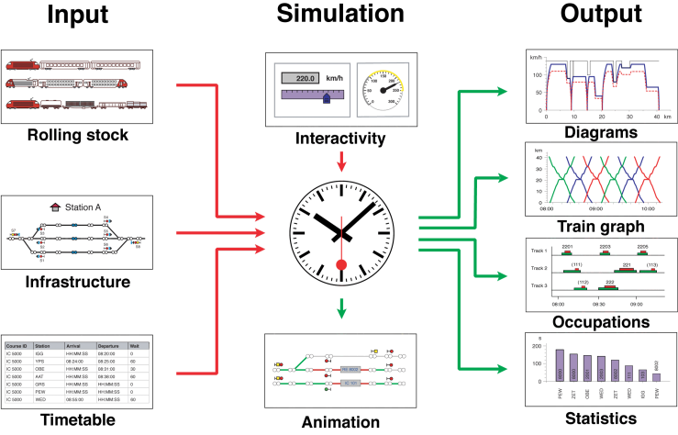
Figure 2. Data flow in simulation of railway operation
Input Data
OpenTrack manages input data in three modules: rolling stock (trains), infrastructure, and timetable. Users enter input information into these modules and OpenTrack stores it in a database structure. Once data has been entered into the program, it can be used in many different simulation projects. For example, once a certain locomotive type has been entered into the database, that locomotive can be used in any simulation performed with OpenTrack. Similarly, different segments of the infrastructure network can be entered separately into the database and then used individually to model operations on the particular segment or together to model larger networks.
Train data (locomotive and wagons) is entered into the OpenTrack database with easy to use forms displayed using pull down menus. Infrastructure data (e.g. track layout, signal type/location) is entered with a user-friendly graphical interface; quantitative infrastructure data (e.g. elevation) is added using input forms linked to the graphical elements. Following completion of the railML (railMl) data structure for rolling stock and infrastructure, OpenTrack is modified to enable train and infrastructure data to be directly imported from railML data files.
Timetable data is entered into the OpenTrack database using forms. These forms include shortcuts that enable data input to be completed efficiently. For example, users can designate hourly trains that follow the same station stopping pattern an hour later. Since OpenTrack uses the railML (railML) structure for timetable data, timetable data can also be entered directly from various different program output files as well as database files. Furthermore, Figure 3 shows a short overview of different software programmes using railML interface.

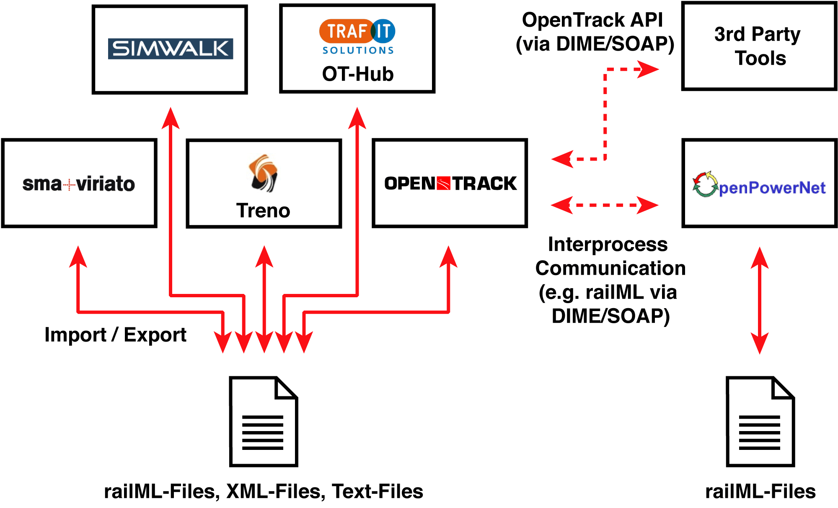
Figure 3. Example of software tools already using
One advantage of OpenTrack is that it enables users to adjust many variables that impact railroad operations. For example, users can simulate the impact of weather on traction by specifying the adhesion scenario (good, normal, bad). OpenTrack then estimates locomotive traction power using a percentage (also user-defined) of that calculated using the Curtius and Kniffler formula (Huerlimann, 2001). While OpenTrack provides standard default values for all variables, having the ability to adjust variables makes the program very useful.
Simulation
In order to run a simulation using OpenTrack the user specifies the trains, infrastructure and timetable to be modelled along with a series of simulation parameters (e.g. animation formats) on a preferences window. During the simulation, OpenTrack attempts to meet the user-defined timetable on the specified infrastructure network based on the train characteristics. OpenTrack uses a mixed continuous/discrete simulation process that allows a time driven running of all the continuous and discrete processes (of both the vehicles and the safety systems) under the conditions of the integrated dispatching rules.
The continuous simulation is dynamic calculation of train movements based on Newton’s motion formulas. For each time step, the maximum force between the locomotive’s wheels and the tracks is calculated and then used to calculate acceleration. Next, the acceleration function is integrated to provide the train’s speed function and is integrated a second time to provide the train’s position function (Huerlimann and Nash, 2003).
The discrete simulation process models operation of the safety systems; in other words, train movements are governed by the track network’s signals. Therefore, parameters including occupied track sections, signal switching times, and restrictive signal states all influence the train performance. OpenTrack supports traditional multi-aspect signalling systems as well as new moving block train control systems (e.g. European Train Control System – ETCS signalling).
OpenTrack is a dynamic rail simulation program. As such, the simulated operation of trains depends on the state of the system at each step in the process as well as the original user-defined objective data (e.g. desired schedule).
A simple way of describing dynamic rail simulation is that the program decides what routes trains use while the program is running. For example, when building the network, users identify various different routes that trains can use between two points; OpenTrack decides, during the simulation, which route the train will use by assigning the train the highest priority route available. If the first priority is not available, OpenTrack will assign the train the second highest priority route and so on.
OpenTrack’s dynamic nature allows users to assign certain attributes to specified times in the simulation. Thus, users can assign a delay to a particular train at a given station and time, rather than being limited to assigning a delay at the start and using it through the entire simulation. Similarly, users can define other types of incidents (e.g. infrastructure failures, rolling stock breakdowns) for particular times and places.
Finally, dynamic simulation enables users to run OpenTrack in a step-by-step process and monitor results at each step. Users can also specify exactly what results are displayed on the screen. Running OpenTrack in a step-by-step mode with real time data presented on screen helps users to identify problems and develop alternative solutions.
Output
One of the major benefits of using an object-oriented language is the great variety of data types, presentation formats, and specifications that are available to the user. During the OpenTrack simulation each train feeds a virtual tachograph (output database), which stores data such as acceleration, speed, and distance covered. Storing the data in this way allows users to perform various different evaluations after the simulation has been completed.
OpenTrack allows users to present output data in many different formats including various forms of graphs (e.g. time-space diagrams), tables, and images. Similarly, users can choose to model the entire network or selected parts, depending on their needs. Output can be used either to document a particular simulation scenario or as an interim product designed to help users identify input modifications for another model run (OpenTrack Railway Technology).

OpenTrack and API
The Open Track API (application programming interface) is able to communicate with a 3rd party application (over the internet). As in Figure 4 shown, OpenTrack accepts Commands (messages to OpenTrack) and sends Status Messages (Messages from OpenTrack). Most importantly, these messages are designed such that they correspond to those exchanged in a real-world railway system between trains, interlocking and dispatching units. For example, massages received from OpenTrack can be train, timetable and block/routes Messages, arrival and departure times at stations, interlocking messages and others. On the other hand, OpenTrack sends speed commands, timetable changes, dispatching decisions that resulted from dynamic simulation. Figure 4 shows an example of OpenTrack Dispatcher. In this case, OpenTrack acts as the replacement of the reality, since the same type of information is exchanged as in reality; namely, commands (messages) go to OpenTrack, whereas Status Messages come from OpenTrack (OpenTrack Railway Technology).
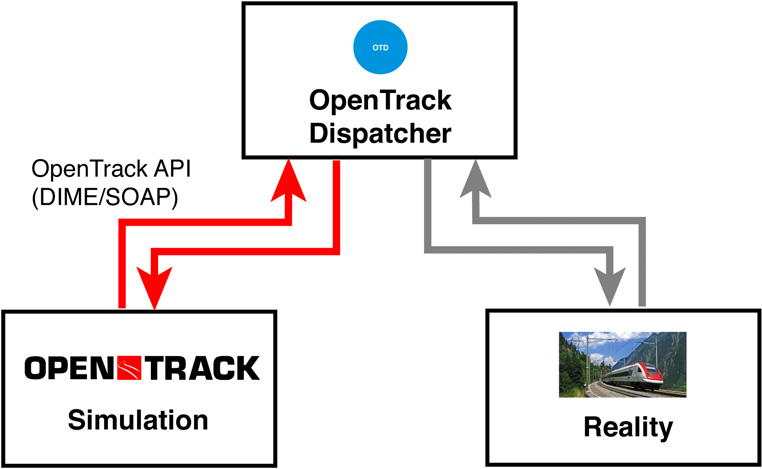
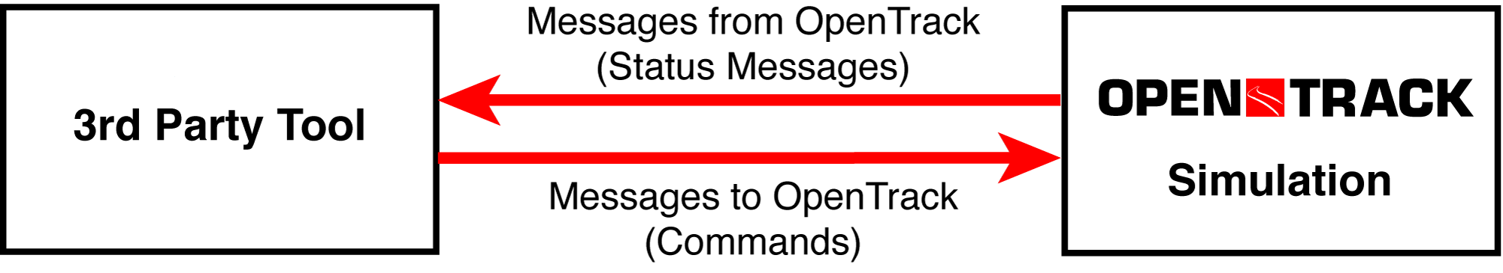
OpenTrack API’s application offers an unlimited number of possibilities, starting from implementation of customer-specific dispatching algorithms to in-depth evaluation of railway operations, connections between trains and circulation of train sets. However, for GoSAFE RAIL project is the possibility of development and analysis of new concepts in train control, such as optimization of energy consumption, reduction of delays and avoidance of bottlenecks and conflicts of greatest importance. This will provide support to IMs for achieving maximum amount of time slots for railway undertakings and for punctual operation. Finally, the goal is that simulation of the behavior of the reality proves that the optimization algorithm provides suitable solutions within a short period of time.
Figure 4. Example for the application of the OpenTrack API

Case study: zagreb-rijeka line
As already mentioned, line Zagreb – Rijeka was chosen for the case in collaboration with Croatian Railways. First reason is its importance within domestic traffic network; second and more important reason, it being part of TEN-T corridor.
Figures 5 and 6 show examples of infrastructure from the case study. Infrastructure data has been successfully imported in OpenTrack, as it can be seen in these graphical representations of topology. For this paper, just few examples that best reflect the possibilities of OpenTrack were selected. This can be seen in Figure 5, where one can see a detailed presentation of the main railway station in Zagreb, Glavni Kolodvor, whereas the Figure 6 shows part of the preselected network for the case study Zagreb - Rijeka, namely from Hrvatski Leskovac, via Horvati, Mavracici, Zdencina, Desinec, Jastrebarsko, Domagovic, Lazina to Draganici.
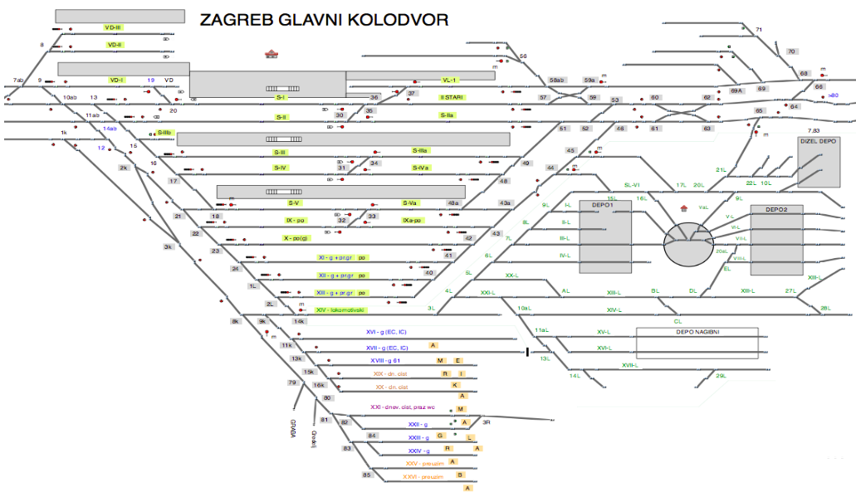
Figure 5. Infrastructure in OpenTrack: Zagreb Glavni Kolodvor
Infrastructure topology includes all signals, stations and information about radius, gradient and speed profile on every kilometre point. Train graph, seen in the Fig.7, shows the timetable for different train categories; namely, cargo, fast or the regional trains. Furthermore, for the clear overview, the period between 3PM and 10PM was chosen and includes blocking time stairway.
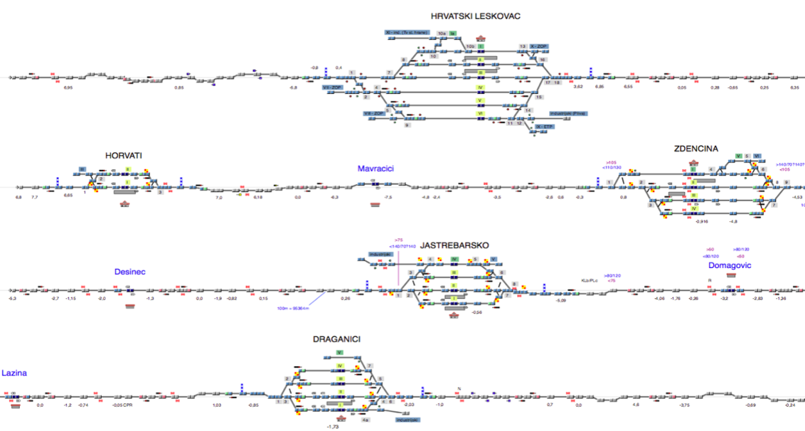

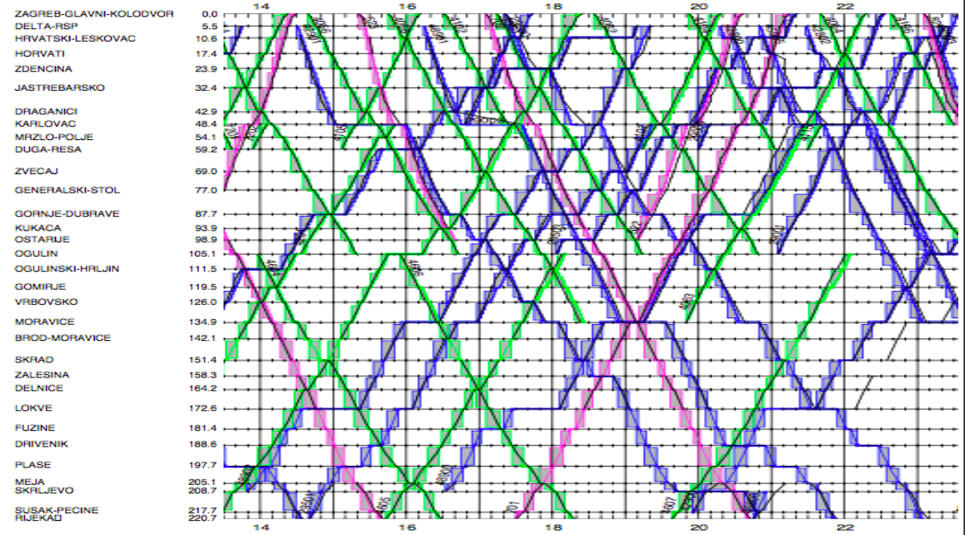
Figure 6. Infrastructure in OpenTrack: Hrvatski Leskovac-Draganici
Figure 7. Train Graph: Zagreb Glavni Kolodvor-Rijeka

Conclusion
In conclusion, GoSAFE RAIL project will provide a means of virtually eradicating sudden infrastructure failures. OpenTrack, being a sophisticated micro-simulation model with API function, will allow the determination of impact of safety decisions on network capacity. Thus, by incorporating both infrastructure asset (e.g. crossings, tracks, bridges, tunnels) and traffic (e.g. vehicle, freight and passenger movement), effective delivery of maintenance or new works while maximizing the connectivity and adaptability of the overall surface system will be enabled. Finally, the maximization of the availability of the transport network leads to minimization of environmental impacts, such as carbon emissions, and reduction of delays up to 40%. This will be shown in the next project period.

Acknowlegment
GoSAFE RAIL project has received funding from European Union’s Horizon2020 research and innovation programme Shift2Rail under grant agreement No 730817.

REFERENCES
European Railway Agency, Intermediate report on the development of railway safety in the European Union 2013. http://www.era.europa.eu/document-register/documents/spr%202013%20final%20for%20web.pdf (accessed 13.08.2017)
Gibson, J. Train Performance Calculators and Simulation Models. Handout, Transportation Research Board, “TRB Workshop on Railroad Capacity and Corridor Planning.” January 13, 2002.
GoSAFE Rail project: http://www.gosaferail.eu (accessed 22.08.2017)
Huerlimann, D. Object oriented modeling in railways; ETH Dissertation Nr. 14281; 2001.
Huerlimann, D. and Nash, A. OpenTrack – Simulation of Railway Networks. User Manual Version 1.3; ETH Zurich, Institute for Transportation Planning and Systems; May 2003; Page 58.
Luethi M. (2009): Structure and Simulation Evaluation of an Integrated Real-Time Rescheduling System for Railway Networks, Journal of Networks and Spatial Economics, vol 9, Issue 1, pp. 103-121.
Mittermayr, R., Blieberger, J. and Schöbel, A. 2012. Kronecker algebra-based deadlock analysis for railway systems. Traffic Planning. 24(5): 359-369.
OpenTrack Railway Technology: www.opentrack.at
railML: www.railml.org
Volcic, M. 2014. Energy-efficient Optimization of Railway Operation: An Algorithm on Kronecker Algebra. Dissertation: Vienna University of Technology.

