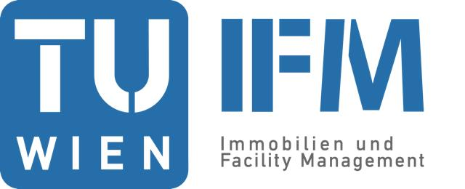

Journal
für
Facility Management
Wissenschaft trifft Praxis

Heft 20/2020

ISSN 2415‐1858

Journal für Facility Management
Heft 20/2020

ISSN 2415-1858
www.ifm.tuwien.ac.at
Preface of the publisher
20. Journal for Facility Management:
Science meets Practice

The year 2020 started as usual, and then, mid of March, everything was different. From one moment to the next flying, meeting, seeing friends was almost impossible. A lot of studies envision COVID-19 as a game changer. I consider the pandemic as an accelerator. Existing trends and challenges were speeded up or made visible due to the pandemic.
New ways of working were already a hot topic in the last years. We could see a lot of discussions how the new office should look like. There was already a discussion, if and how to include home office in the new work environment. Due to COVID-19 companies were forced to use home office. Home office was the only way to enable business continuity. But companies also learned that they have to enable their employees to work from home. The first steps were to enable access to documents from everywhere and video conferencing as physical meetings were not possible at all.
Years ago, Diane Coles Levine was already giving a presentation on activity-based working and the enablement of home office at the IFM congress in Vienna. At this time, she was with a large health care insurance provider in the Bay area. She stressed the importance of setting up home office in a right way to secure data security and work life balance. But she also described the limitation of home office. For example, her company limited home office to two days per week to secure social binding, learning and interaction.
COVID-19 made these difficulties more visible than before. Working from home kept the business running, but social binding was lost or not build up. How to gain trust when you do not know people and you have no possibility to meet in person? Onboarding without physical meeting? Teaching on distance? How could a fair deal regarding costs and efforts look like? How to secure work life balance?
Also, digitalization of the core business was speeded up by COVID-19. Offerings had to be made to the clients via the web, as shops were closed down totally. Clients were accepting or better had to accept these new ways of interaction and procurement to fulfil their demands.
A lot of challenges. Therefore, this issue of Journal für Facility Management provides you with insights into the development of the industry and workplace management:
- The Upwards Trend of the Outsourced Facility Service Industry in Germany and Austria
- How do people from different generations approach work? Implications for workspace design
- New World of Work characterized by the digitalization and flexibility. Change Management and Facility Management at the heart of change.
- Implementation of a virtual occupancy sensor for smart building support
The last worldwide economic crisis happened after 2008. The first paper shows that according to EU statistics the FS industry grew faster than the rest of economy in Germany and Austria between 2008 and 2016 in terms of value added and full-time equivalents. In Germany, there were no decreases for any FS activities in terms of profits, value added, personnel costs or wages. This points out that this industry supported the economic recovery after 2009.
The second paper makes a connection between the Sustainable Development Goals (SDG) and the meaning of work for the motivational theory. The authors performed a field study to find solutions for the multi-generational environments fostering skill and experience sharing. The solution takes care on cultural identities and changes in motivational patterns.
The third paper covers the effects of changes of physical workplaces triggered by trends like digitalization and flexibilization. As the world is Volatile, Uncertain, Complex, Ambiguous (VUCA) Facility Managers are to support new way of working, collaborative work and activity-based working (ABW) strategies with real and virtual office concepts understanding psychological and sociological interactions between people and space. Co-operation of FM, HR and IT is necessary to achieve workspaces fostering networking, interconnection and health. Mere cost reduction is not enough anymore.
The last paper provides more insight in predicting occupancy patterns. Having access to either real-time presence data or patterns extracted from historical data is particularly valuable when dealing with facility design. The paper proposes a cost effective and privacy-preserving method to extract the occupancy information. By aggregating semantic knowledge, motion sensor data and data from dwelling entrance doors, a robust virtual occupancy sensor has been developed.
These articles are giving answers to day-to-day problems for the time after COVID-19 that we need to be prepared for. At this point, I want to thank all international researchers who sent us numerous abstracts and papers for the double-blind review. The decline rate was kept high with more than 50%. The high-quality research handed in enabled us to increase the quality of the IFM journal over the last years. Thanks for your help, and we are looking forward for your future support. I also want to thank the members of the editorial and the scientific board for their terrific work. They supported me in reviewing first the abstracts and then the full papers and gave a lot of input to the authors.
The high decline rate, the high reputed members of the editorial and the scientific board and the supporting universities ensure that the articles are not only having a high scientifically quality, but also that practitioners can put them into practice easily.
I also want to thank my team, especially Larissa Locsmandy und Mag. Barbara Gurdet. Without their personal engagement, the journal would not be available in this high quality.
I wish you all the best from Vienna, an enjoyable read, a lot of input for your research and/or for your daily work. I look forward to a lot of new abstracts and papers for the next call for papers for the 14th IFM congress 2021.
Stay healthy,
Alexander Redlein
Head of Editorial Board
To my family: Barbara, Caroline Sidonie und Alexander David
Scientific Committee
Prof. Dr. Alexander Redlein
Institute of Management Science, Real Estate and Facility Management, TU Wien, Austria

Prof. Jan Bröchner
Department of Technology Management and Economics, Chalmers University of Technology, Göteborg, Schweden

Prof. Roscoe Hightower, Jr., PhD
FAMU - Florida Agricultural and Mechanical University, USA

Prof. Dr. Wolfgang Kastner
Institute of Computer Engineering, TU Wien, Austria

Dr. Joseph H. K. Lai
Department of Building Services Engineering, The Hong Kong Polytechnic University, Hong Kong

Prof. Dr. Kurt Matyas
Institute of Management Science, TU Wien, Austria

Prof. Sergio Vega Sánchez
Universidad Politécnica de Madrid, Spain

Herausgeber / Editorial Board
Prof. Dr. Alexander Redlein (Head of Editorial Board)
Institute of Management Science, Real Estate and Facility Management, TU Wien, Austria

Prof. Dr. Dr. h.c. Dr. h.c. Jörg Becker, Professor h.c.
Chair for Information Systems and Information Management, WWU Westfälische Wilhelmsuniversität, University of Münster, Germany

Prof. em. Dr. Wolfgang Janko
Department of Information Systems and Operations, WU Vienna University of Economis and Business, Austria

Organisation
Mag. Barbara Gurdet und Larissa Locsmandy
Institute of Management Science, Real Estate and Facility Management, TU Wien, Austria

Vielen Dank an alle KollegInnen des IFM für die Mithilfe bei der Organisation!
Inhaltsverzeichnis / table of contents

7 | Science meets Practice I: Strategy and Workplace
8 | New World of Work characterized by the digitalization and flexibility. Change Management and Facility Management at the heart of change.  R. Skreta  Österreichische Galerie Belvedere
29 | How do people from different generations approach work? Implications for workspace design  S. Capotescu  ErgoWork Society Romania  I. Mohora  Politehnica University, Timisoara  H. Soim  Vasile Goldis Western University, Arad
50 | Science meets Practice II: Technology and Operation
51  66 | Implementation of a virtual occupancy sensor for smart building support  J. Aizpuru  R. Jentsch  M. Šipetić  G. Zucker  AIT Austrian Institute of Technology, Austria  The Upwards Trend of the Outsourced Facility Service Industry in Germany and Austria  E. Stopajnik  Technische Universität Wien, Immobilien und Facility Management
The Upwards Trend of the Outsourced Facility Service Industry in Germany and Austria
Mag. Eva Stopajnik
TU Wien, Immobilien und Facility Management
Abstract

The Facility Service (FS) industry is a growing industry. A study (Redlein and Stopajnik 2019) showed that the FS industry grew faster than the rest of economy in Germany and Austria between 2008 and 2016 in terms of value added and employees. To get a better understanding of this development further analysis are necessary: The influence of part time workers is not yet clear and it is not yet clear if the development of value added is driven by personnel costs or profits. Furthermore, it is necessary to investigate which specific FS activities led to that increase.

To answer these questions EU statistics and European norms are used: The European standard EN 15221-4 lists all services that can be considered FS. Eurostat lists economic activities on a detailed level. Those activities are matched with the activities of the EN 15221-4. The selected items of statistics from Eurostat are used to determine the FS industry. As measures full-time equivalents, wages and salaries, personnel costs and profits are selected next to valued added at factor cost and the number of employees. Based on this approach, the development of the FS industry is analysed. To make a comparison possible the FS industry is set into relation to the whole business economy for each measure.

Results show that in Austria and Germany high increases can be registered in the FS activities cleaning, janitoring, building installations and security. Results show that the FS industry grew faster than business economy in terms of full-time equivalents. In Germany, there were no decreases for any FS activities in terms of profits, value added, personnel costs or wages and salaries. In Austria some FS activities such as steam and air conditioning supply, water treatment and supply showed slight decreases.
Keywords: Facility Services, industry growth, employment, value added

- Introduction

The Facility Service (FS) industry grew faster than the rest of economy in Germany and Austria between 2008 and 2016 according to a study (Redlein and Stopajnik 2019). The selected measures for the time series were value added and the number of employees. In order to get a better understanding of this development further analysis of measures and their relations are necessary: The influence of part time workers is not yet clear and it is not yet clear to which extent the development of value added is made up by personnel costs and profits. Furthermore, it is necessary to investigate which specific FS activities led to that increase. Therefore, the research questions are:

- Which specific FS activities cause the upwards trend of the outsourced FS industry between 2008 and 2016 in Germany and Austria?
- What influence do the measures full-time equivalents, wages and salaries, personnel costs and profits have on the development of the outsourced FS industry?

- Background

There is a lack of reports and analysis of the FS industry. This is mainly due to the fact that the FS industry as a whole is not represented in the Statistical Classification of Economic Activities in the European Community, called NACE. (European Commission 2008) NACE is the official classification system of industries in the EU and all EU member states. Most official reports about industries are based on this statistical classification. As the FS industry as a whole is not listed in the classification, it is also not listed in the reports and therefore lacks recognition.

Furthermore, there are different understandings of Facility Management (FM) and FS in different countries and organisations. Around 2006 FM still has been a developing business area. To create a common understanding and approach of FM and FS the European norm EN 15221 was created. This was also necessary to increase transparency. (British Standards 2007, EuroFM 2011). In this norm FS is defined as “support provision to the primary activities of an organisation, delivered by an internal or external provider”. (British Standards 2007) In 2012 the norm was extended and a list of activities that can be considered FS was added and published in the fourth part of the norm: EN 15221-4 (British Standards 2012). For this analysis the list published by the EN is used.
The NACE structure is also used by Eurostat, the data base of the European Commission. Eurostat provides a huge open-access data base for governments, businesses, the public and anyone else interested. (European Commission 2019a) Part of the database are also Structural Business Statistics (SBS). The data displayed in SBS is collected by the national statistical offices of the EU member countries and annually transmitted to Eurostat. National statistical offices collect the data from other administrative sources, business registers or with the help of surveys. SBS include annual enterprise statistics in which data about the number of enterprises, turnover, production value, value added, employment, etc. is provided. This data is available on the most detailed level of the NACE structure, so data for several hundred economic sectors is there. SBS include all sectors of business economy except for agriculture and personal services. (European Commission 2019b)

In the previous study the measures number of employees and value added at factor cost were selected. (Redlein and Stopajnik 2019) The number of employees includes part time and fulltime employees. As the proportion of part time workers can vary between industries this has to be taken into account. The second measure gross value added at factor cost “can be calculated from the gross operating surplus by adding personnel costs”. (European Commission 2013) As it mainly consists of personnel costs in most industries it’s also an indicator for income. Therefore, it would be crucial for the analysis of the industry to find out if profits rose and if employees profited from the increase. As income is spent by the people that earn it, it is given to other people and creates further value this way.

- Methodology
To answer the research questions the data from Eurostat and the EN 15221-4 were used: The list of services that are FS from the EN 15221-4 was compared to the NACE structure on the most detailed level. So, the relevant industries for FS were identified. They were grouped into the two groups “Typical Facility Services” and “General Facility Services”. Typical FS for the operation of business and residential buildings cover activities such as cleaning, maintenance, janitorial services and security services. General FS include services such as water supply, sewerage, waste management, office and administrative support services.
Then the data base of Eurostat was analysed. First the relevant measures to answer the research question were chosen. Next to value added at factor cost and employees the following measures were selected: Personnel costs, gross operating surplus, wages and salaries and employees in full time equivalent units.
The data for those measures for Austria and Germany were selected for 2008 until 2016 from Eurostat and checked for their plausibility and reliability. First the data sets were checked for missing values. For the determination of the FS industry only years are shown when the data sets were complete or if missing subindustries were less than 0,75% of Total FS in the other years. Secondly the continuity over time was checked. Thirdly, ratios such as value added per factor cost were calculated as a plausibility check. Fourthly outliers and their causes were investigated. The checks showed that all data could be used for the calculation, only data for the financial sector had to be excluded. The financial sector is only recorded from 2013 onwards and there is too much missing data, so that this sector would provoke extreme dips due to that.
As a relation total-nonfinancial business economy was determined, to make a comparison between measures possible. The data is presented in percentage of total non-financial business economy and in absolute numbers.

- Results
Employment
The first analysis concentrates on the question why the FS industry shows such a great increase in employees. As the previous analysis didn’t differentiate between part- and fulltime workers, the graphic shows the number of fulltime-equivalents (FTE) working in FS in Austria and Germany from 2008 to 2016. The graphic shows that in Germany the number of FTE in FS and in total-nonfinancial business economy increased constantly. This also happened in Austria in FS but compared to Germany the increases were smaller so that it is not visible in the graph. In Austria from 2008 to 2016 the FS sector gained about 20.000 FTE. Also, total nonfinancial business economy increased constantly in Austria, only in 2009 and 2010 after the economic crisis it decreased. This shows that the FS industry is quite robust during and after recession. As the previous study already stated, there are certain FS activities such as maintenance, janitorial services, services connected to water supply and waste management that are very important. Even during a crisis, they cannot just be cut. (Redlein und Stopajnik 2019)
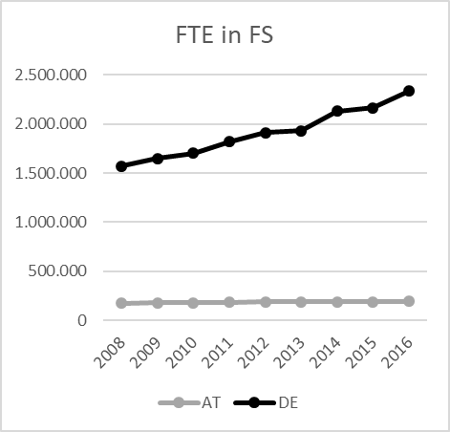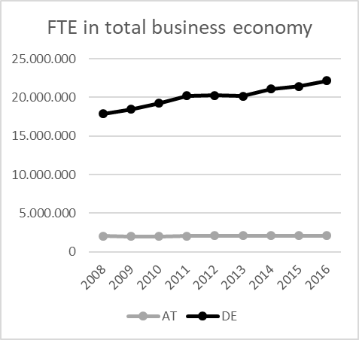
Fig. 1. Left: FTE in total FS, right: FTE in total non-financial business economy, own calculation on the base of annual detailed enterprise statistics (European Commission, last modified 2019)

Fig. 2 shows the proportion of FS-employees in total non-financial business economy in FTE and number of employees separately for the two countries. In Austria there is almost no difference between the proportion of FTE and the proportion of the number of employees. This means that in the FS industry employees have almost the same average working hours as in total non-financial business economy. However, there is also a slight upwards trend visible. This means that actually the FS industry grew a little bit faster than total economy.
In Germany, there is a huge difference concerning the proportions of the FTE and the numbers of employees. Both follow the same trend but the proportion of the number of employees in percentage of total number of employees in non-financial business economy is much higher. This can be explained by fewer average working hours in FS than in the rest of business economy. Based on the assumption that a FTE works 40h per week, employees in FS in Germany work on average around 25 to 26 hours per week, while employees in business economy rather work 30 to 31 hours per week. In Austria the average working hours for employees in FS and in business economy are about 30 to 32 hours. (Own calculation based on the SBS from Eurostat (European Commission, last modified 2019))
However, the over-proportional increase of FS employees in Germany cannot be explained by that because also FTE increase over-proportionally compared to total FTE in business economy. So, a deeper analysis including other industries and the subindustries of FS is necessary.
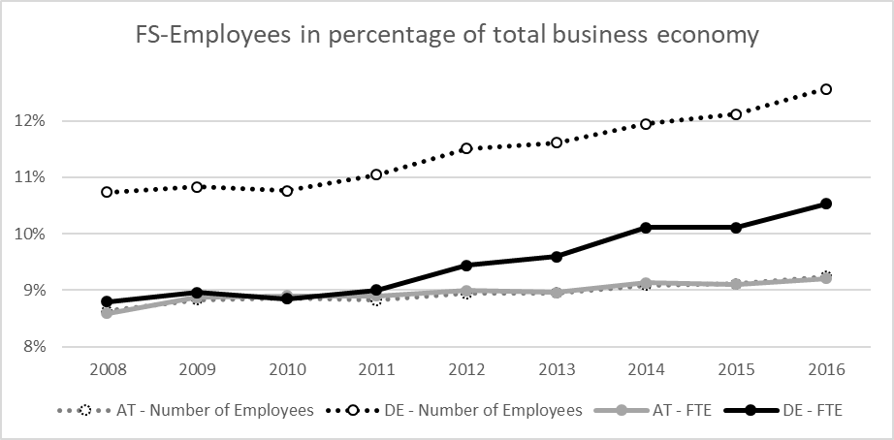
Fig. 2: Number of employees as a percentage of number of employees in non-financial business economy and FTE as a percentage of FTE in non-financial business economy, own calculation on the base of annual detailed enterprise statistics (European Commission, last modified 2019)

Analysis of subindustries and other aggregated industries
A deeper analysis in Austria shows that the increases in the FS industry were mainly due to three subindustries: The subindustry general cleaning of buildings gained almost 9000 FTE, janitorial services gained approx. 4100 FTE and building installations gained almost 5000 FTE from 2008 to 2016. Considering a total increase of about 20000 employees in FS this shows that the increase is made up by typical FS. The other subindustries showed slight positive or negative changes.
A comparison of the FS industry and the other aggregated industries shows that the transportation and storage sector, the manufacturing sector, mining and quarrying and electricity, gas, steam and air conditioning supply show decreases. That could be the reason why the FS industry increased over-proportionally to total business economy.

An analysis of the FS industry in Germany shows immense increases in certain subindustries from 2008 to 2016: In building installations there is an increase of more than 200000 FTE, general and specialized cleaning of buildings gained 140000 FTE, catering increased by around 100000 FTE, security services by approx. 70000 and janitorial services by 40000 FTE. This is already more than half a million FTE.
On the other hand, other aggregated industries showed a decrease like the mining and quarrying sector or only very slow growth like gas and electricity supply. So, in terms of employees it must be stated that it is correct that the FS industry grew faster than total non-financial business economy. In Germany it is partly due to a lower number of working hours in FS.

Other measures
Due to missing values in Germany an analysis for the measures value added, profits, personnel costs and wages and salaries are only possible from 2011 onwards.
In Germany there were no decreases for any FS activities in terms of profits, value added, personnel costs, wages and salaries between 2011 and 2016. Only a small decrease in wages and salaries per full-time equivalent for move management and specialized cleaning of buildings is visible. The over-proportional increase rather results from decreases in other industries of business economy such as mining and quarrying (for all variables) and electricity and gas sector (value added and profits) and transportation and information and communication (only profits).
In Austria the same decreases can also be seen in the sectors of mining and quarrying and electricity and gas. However, in Austria the situation of the FS industry is a bit different: While the FS industry as a whole increased over-proportionally to business economy some FS activities also show slight decreases. Namely steam and air conditioning supply, water treatment and supply and combined office administrative service activities decreased in terms of full-time equivalents, personnel costs and wages in total and wages per full-time equivalents. The reason for this decrease may be that offices were still rented but the use decreased. Therefor these operating costs depending on the current usage decreased.
Losses in profits were registered for catering activities, steam and air conditioning supply and the management of real estate. All in all, it can be stated that the need for very typical FS activities has been increasing in the past years.

Value added, personnel costs and profits
Fig. 3 shows gross value added at factor cost and its components profits (gross operating surplus) and personnel costs in million euro for the FS industry and total non-financial business economy for both countries separately. It is visible that the personnel costs are increasing constantly – this is going hand in hand with the development of the FTE. The graph also shows that the variations in value added are the same as in profits. Not surprisingly this shows again that employment is much more stable than profits. A crisis first affects profits. This has different reasons, one might be that the firing and recruiting processes take some time and there are legal obstacles to lay off too many employees without previous notice.
Profits in Germany and Austria in the FS industry are between 32% and 38% of value added, in Germany they are a bit higher.

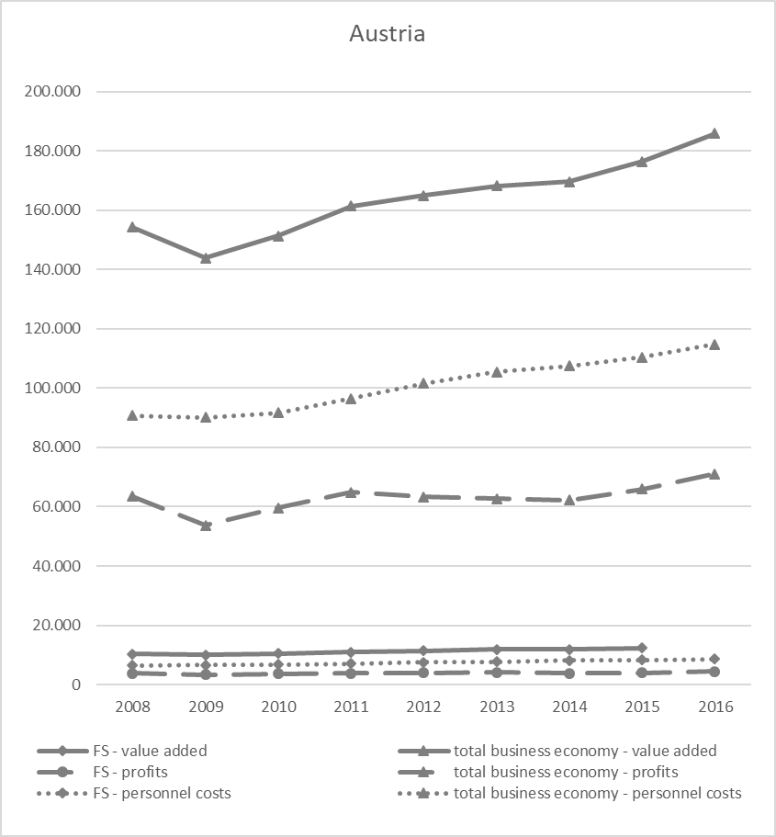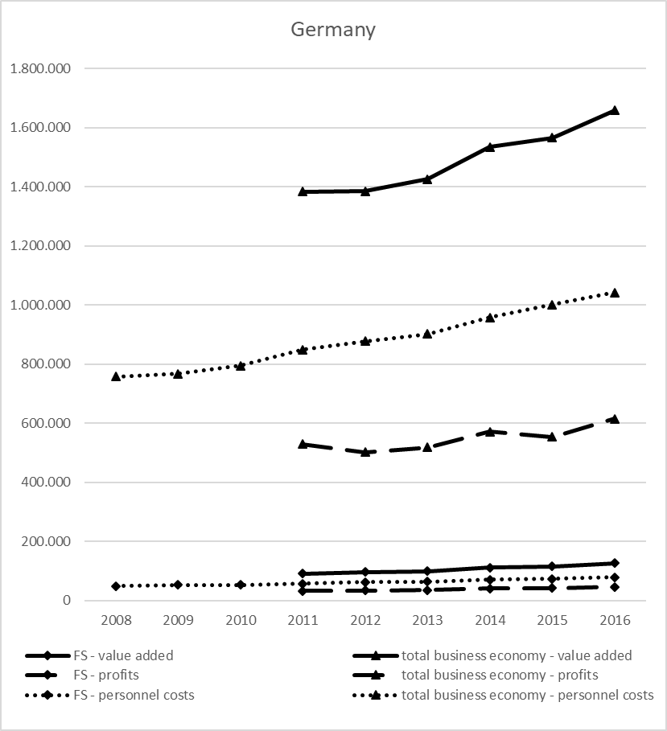
Fig. 3.: Value added at factor cost, profits and personnel costs in million euro in the FS sector and total non-financial business economy, left: Austria, right: Germany, own calculation on the base of annual detailed enterprise statistics (European Commission/Eurostat, last modified 2019)

- Conclusion
Results show that in Austria and Germany enormous increases can be registered in the FS activities cleaning, janitoring, building installations and security. Results show that the FS industry didn’t only grow faster than business economy as a whole in terms of employees but also in terms of full-time equivalents. The main reason for that is that other industries increased less or decreased. However, in Germany the lower number of working hours in FS might partly be influencing this trend also.
In Germany, there were no decreases for any FS activities in terms of profits, value added, personnel costs or wages and salaries. The over-proportional increase rather results from decreases in other industries of business economy such as mining and quarrying, electricity and gas sector, transportation and information and communication. In Austria the same decreases can also be seen in the sectors of mining and quarrying and electricity and gas. However, in Austria the situation of the FS industry is a bit different: While the FS industry as a whole increased over-proportionally to business economy some FS activities also show slight decreases. Namely steam and air conditioning supply, water treatment and supply and combined office administrative service activities decreased in terms of full-time equivalents, personnel costs and wages in total and per full-time equivalents. Losses in profits were registered for catering activities, steam and air conditioning supply and the management of real estate. All in all, it can be stated that the need for very typical FS activities has been increasing in the past years. The analysis of value added, personnel costs and profits show that employment is much more stable than profits. This is helpful during a recession because people longer receive an income which is spent again and so creates income for other people.

References
British Standards (2007): EN 15221-1:2006: Facility Management - Part 1: Terms and definitions, by CEN, Bruxelles, Belgium.
British Standards (2012): EN 15221-4:2011: Facility Management – Part 4: Taxonomy, Classification and structures in Facility Management, by CEN, Bruxelles, Belgium.
European Facility Management Network (EuroFM) (2011): EuroFM Market Data Report 2011, Bruxelles, Belgium.
European Commission (last modified 2019). Detaillierte jährliche Unternehmensstatistiken für das Baugewerbe (NACE Rev. 2, F), Detaillierte jährliche Unternehmensstatistik für den Handel (NACE Rev. 2, G), Detaillierte jährliche Unternehmensstatistik für Dienstleistungen (NACE Rev. 2, H-N und S95), Detaillierte jährliche Unternehmensstatistiken für die Industrie (NACE Rev. 2, B-E), in structural business statistics (sbs), available at: http://ec.europa.eu/eurostat/search?p_auth=vsrRef94&p_p_id=estatsearchportlet_WAR_estatsearchportlet&p_p_lifecycle=1&p_p_state=maximized&p_p_mode=view&_estatsearchportlet_WAR_estatsearchportlet_action=search&text=Detaillierte+j%C3%A4hrliche+Unternehmensstatistik (accessed 17.1.2019 and 26.3.2019)
European Commission (2019a): Overview, available at: https://ec.europa.eu/eurostat/about/overview, (accessed 10.9.2019)
European Commission (2019b): Structural business statistics (sbs) - Reference Metadata in Euro SDMX Metadata Structure (ESMS), available at https://ec.europa.eu/eurostat/cache/metadata/en/sbs_esms.htm (accessed 10.9.2019)
European Commission (2013): Glossary:Value added at factor cost, available at: https://ec.europa.eu/eurostat/statistics-explained/index.php/Glossary:Value_added_at_factor_cost (accessed 4.4.2019)
European Commission (2008): NACE Rev. 2 – Statistical classification of economic activities in the European Community, Luxembourg, available at: https://ec.europa.eu/eurostat/documents/3859598/5902521/KS-RA-07-015-EN.PDF (accessed 4.4.2019)
Redlein, A. & Stopajnik, E. (2019): The Facility Service Industry as a Driver of Economy, in ARES Conference. Phoenix, USA.

