SCHOOL ON CATALYSIS

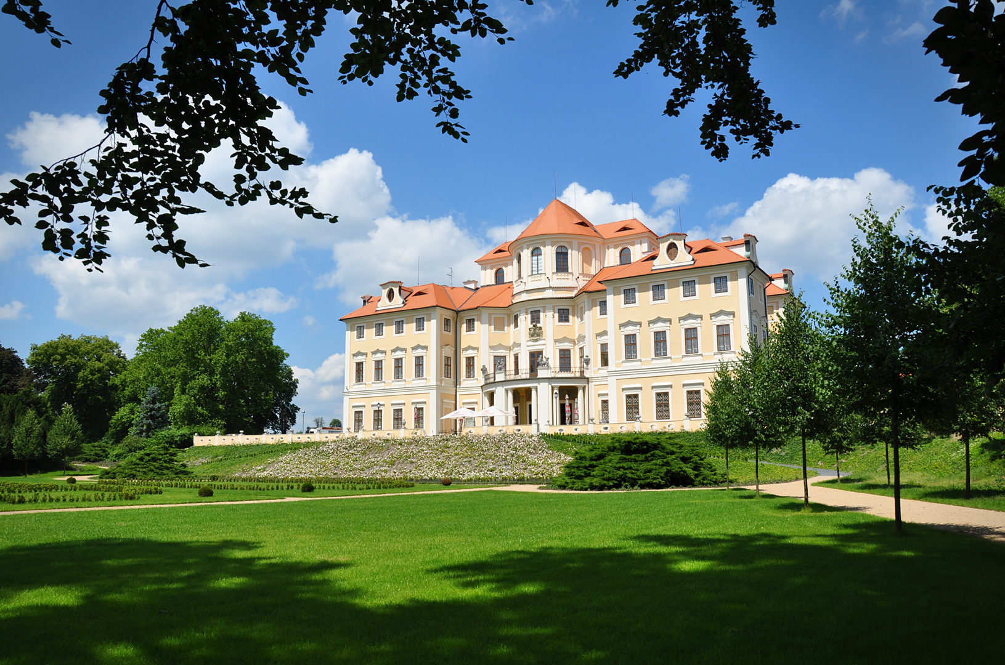

Liblice, October 4-6, 2021

Monday, October 4
12:00 Bus Departure from the Prague Airport to Liblice
13:00-14:00 | Registration
14:00-14:05 |  | Opening and Introduction
 |  | Chair: Jiří Čejka
14:05-15:00 | PL1 | Opportunities and challenges for catalysis in the energy transition  Nikolai Nesterenko (Total, France) – ZOOM presentation
15:05-15:55 | PL2 | On-surface UHV chemistry and scanning probe microscopy  Pavel Jelínek (FZU, Czechia)
16:00 |  | Guided Tour to Brewery Lobeč
19:00 | Welcome (Garden) Party – depending on the weather
 |  | Tuesday, October 5
 |  | Chair: David Kubička
8:30-9:25 | PL3 | Circular economy: From Waste to Advanced Fuel  Carlo Perego (eni, Italy) – ZOOM Presentation
9:25-10:20 | PL4 | High pressure NMR spectroscopy in homogeneous catalysis  Werner Oberhauser (NRC, Sesto Fiorentino, Italy) - ZOOM Presentation
10:20-10:50 |  | Coffee Break & Posters
 |  | Chair: Lucie Obalová
10:50-11:30 | PL5 | How to promote your science  Carlos Henrique Vieira Melo (Charles University, Prague, Czechia)
11:30-11:35 |  | Presentation of Ranido company  Pavel Kukula (Ranido, Czechia)
11:35-11:40 |  | Presentation of deepXscan Dresden  Ehrenfried Zschech (deepXscan Dresden, Germany)
12:00-13:15 |  | Lunch
 |  | Chair: Jan Přech
13:15-14:30 |  | Student Oral Presentations – 1-6 (10 minutes/each + 15 minutes for questions)
14:30-15:45 |  | Student Oral Presentations – 7-12 (10 minutes/each + 15 minutes for questions)
15:45-16:15 |  | Coffee Break & Posters
 |  | Chair: Michal Mazur
16:15-17:30 |  | Student Oral Presentations – 13-18 (10 minutes/each + 15 minutes for questions)
17:30-18:45 |  | Student Oral Presentations – 19-24 (10 minutes/each + 15 minutes for questions)
19:30 |  | Dinner
 |  | Wednesday, October 6
 |  | Chair: Carlos Viera
9:00-9:55 | PL6 | Publishing and getting published – an editor's perspective  Philip Loessl (Nature, Berlin)
9:55-10:50 | PL7 | Temperature programmed methods in catalysis  Roman Bulánek (UPCE, Czechia)
10:50-11:25 |  | Coffee Break & Posters
 |  | Chair: Roman Bulánek
11:25-12:15 | PL8 | FTIR (spectroscopy in catalysis)  Marco Daturi (Université de Caen Normandie, France)
12:15-12:20 |  | Closing remarks: David Kubička
12:20-13:00 |  | Lunch
Bus Departure from Liblice to the Prague Airport

ORAL PRESENTATIONS
O1 | Addressing confinement effect in alkenes epoxidation using ‘isoreticular’ titanosilicate zeolite catalysts  S. Abdi, M. Kubů, A. Li, M. Shamzhy - Faculty of Science, Prague
O2 | Preparation of Fe@MFI and CuFe@MFI composite hydrogenation catalysts by reductive demetallation of Fe-zeolites  A. Kurbanova, D. Zákutná, K. Gołąbek, M. Mazur, J. Přech - Faculty of Science, Prague
O3 | Copper coordinated hyper-cross-linked porous polyacetylenes: synthesis and application as heterogeneous organometallic catalysts  D. Šorm, B. Bashta, J. Sedláček, L. Sekerová, E. Vyskočilová - Faculty of Science, Prague
O4 | Physico-chemical changes of boron nitride during oxidative dehydrogenation of propane  M. Sajad, K. Knotkova, R. Bulanek – University of Pardubice
O5 | The temperature dependence of OH group vibration: the effect of confinement and strength of acid sites  R. Bulánek, J. Kotera, J. Vaculík - University of Pardubice
O6 | How do promoters enhance the activity of Cu-based hydrogenolysis catalysts?  J. Aubrecht, V. Pospelova, O. Kikhtyanin, D. Kubička - University of Chemistry and Technology Prague
O7 | Towards efficient Cu-based catalysts for ester hydrogenolysis: the role of copper introduction method  V. Pospelova, J. Aubrecht, O. Kikhtyanin, D. Kubička - University of Chemistry and Technology Prague
O8 | Washcoating and microstructure characterization of catalytic filters for exhaust gas aftertreatment  M. Blažek - University of Chemistry and Technology Prague
O09 | Mixed‐Valence Single‐Atom Catalyst Derived from Functionalized Graphene  A. Bakandritsos, V. Šedajová, M. Otyepka, R. Zbořil - University of Olomouc
O10 | Facile two step preparation of ultra small silver nanoparticles on cyanographene  D. Panáček - University of Olomouc
O11 | Utilization of Cu catalysts for propylenglycol preparation  J. Kocík, J. Kolena, J. Mück – Unicre, a.s.
O12 | Hydrotreating of middle distillates and co-processing with rapeseed oil using sulfur-free PNiMoCx and PCoMoCx catalysts  H. Carmona, E. Svobodová, Z. Tisler, U. Akhmetzyanova- Unicre, a.s.
O13 | Dehalogenation during pyrolysis of plastics: The potential of stepwise pyrolysis in combination with metal sorbents  J. Hubáček, J. Lederer, P. Kuráň- Unicre, a.s.
O14 | Nanoconfinement for production of platform molecules from biosyngas with enhanced selectivity  A.K. Fellenberg, G. Ji, A. Khodakov - Université de Lille
O15 | Liquid and mobile metal promoters for iron catalysts for light olefin synthesis from syngas  A. Barrios, G. Bang, M. Virginie, R. Wojcieszak, V. Ordomsky, J. Thybaut, A. Khodakov - Université de Lille
O16 | Vanadium-loaded zeolites as catalysts for the oxidative dehydrogenation of propane  M. Smoliło-Utrata, K. Samson, M. Gackowski, M. Ruggiero-Mikołajczyk, D. Rutkowska-Żbik - Institute of Catalysis, Cracow
O17 | New insight into the alkali activation of sepiolite - impact on composition, structure and texture  A. Walczyk, A. Michalik, B.D. Napruszewska, J. Kryściak-Czerwenka, R. Karcz, D. Duraczyńska, R.P. Socha, Z. Olejniczak, A. Gaweł, A. Klimek, M. Wójcik-Bania, K. Bahranowski, E.M. Serwicka - Institute of Catalysis, Cracow
O18 | Bimetallic gold catalysts for selective oxidation of ethanol  M. Latschka, G. Pacholik, A. Nagl, A. Limbeck, K. Föttinger - TU Wien
O19 | Novel Doped Perovskite Catalysts – Enhancing Catalytic Activity By Tailored Exsolution of Nanoparticles  L. Lindenthal, J. Popovic, R. Rameshan, T. Ruh, H. Summerer, A. Nenning, A.K. Opitz, S. Löffler, C. Rameshan - TU Wien
O20 | Thermal and catalytic lignocellulose pyrolysis using a continuous reaction system  M. Pagano, H. Hernando, D.P. Serrano – IMDEA Energy/ Rey Juan Carlos University
O21 | Hydrodehalogenation of oils from pyrolysis of WEEE plastic wastes: effect of catalysts and reaction system configuration  L. Amodio, J. López, J. Fermoso, H. Hernando, D.P. Serrano – IMDEA Energy/ Rey Juan Carlos University
O22 | From WEEE plastic wastes to valuable fuels and chemicals: oil production and dehalogenation by catalytic pyrolysis over modified ZSM-5 and USY zeolites  J. López, L. Amodio, H. Hernando, J.M. Moreno, D.P. Serrano – IMDEA Energy/ Rey Juan Carlos University
O23 | Photocatalytic methane conversion under ambient conditions  D. Hu, V.V. Ordomsky, A.Y. Khodakov - Université de Lille
O24 | Meerwein-Poondorf-Verley over Zeolites: finding the route to the alcohol  J.F. Miñambres, J. Přech, J. Čejka - Faculty of Science, Prague

POSTERS
Po01 | Microporous polyacetylene networks with N-alkylpyridinium segments for catalytical and sorption application  A. Hašková, J. Sedláček, B. Bashta, E. Vyskočilová, A. Vagenknechtová - Faculty of Science, Prague
Po02 | Layered zeolite catalysts in a one-pot three-component Prins–Friedel–Crafts catalytic reaction  P. Golis, R. Barakov, Y. Zhang, M. Opanasenko, M. Shamzhy
Po03 | Engineering aspects of advanced titanosilicate catalysts  P. Grussmann, J. Přech- Faculty of Science, Prague
Po04 | Enantioselective Construction of Spirocyclopentane Heteroderivatives Containing Two Spiro Centers  A. Vopálenská, J. Veselý - Faculty of Science, Prague
Po05 | Direct decomposition of NO over K/Co4MnAlOx - Effect of preparation method  T. Bílková, K. Pacultová, K. Karásková, D. Fridrichová, L. Obalová - Technical University of Ostrava
Po06 | Influence of High Temperature Synthesis on the Structure of Graphitic Carbon Nitride and Its Hydrogen Generation Ability  M. Filip Edelmannová, K. Kočí, E. Alwin, R. Wojcieszak, M. Zielinski, M. Pietrowski - Technical University of Ostrava
Po07 | Synthesis of catalysts derived from MgM³⁺ layered double hydroxides and their application in aldol condensation  V. Korolova, O. Kikhtyanin, D. Kubička - University of Chemistry and Technology Prague
Po08 | Controlled Deposition of Platinum Nanoparticles over 2D Materials via Electron Beam Lithography for Catalytic Applications  I. Danylo, M. Vesely, Z. Sofer, P. Marvan, A. Michalcova, L. Lenz - University of Chemistry and Technology Prague
Po09 | Tunable Synthesis of Nitrogen Doped Graphene from Fluorographene under Mild Conditions  D. Zaoralová, V. Hrubý, V. Šedajová, R. Mach, V. Kupka, J. Ugolotti, A. Bakandritsos, M. Medveď, M. Otyepka - University of Olomouc
Po10 | Transparent and Low-Loss Luminescent Solar Concentrators Based on Self-Trapped Exciton Emission in Lead-Free Double Perovskite Nanocrystals  L. Zdražil - University of Olomouc
Po11 | Singlet Oxygen Photosensitization and Photoredox Catalysis by Group 4 Metallocene Complexes with Pendant and Chelating N-Donor Ligands  D. Dunlop, B. Urbán. R. Gyepes, P. Kubát. K. Lang. M. Horáček. T. Slanina. M. Lamač - J. Heyrovsky Institute of Physical Chemistry
Po12 | First ACE unit in the Czech Republic is placed in UniCRE  M. Pšenička, N. Bringlerová, A. Vráblík- Unicre, a.s.
Po13 | Determination of long-term activity of HDS catalyst using accelerated deactivation method  L. Matoušek, A. Vráblík - Unicre, a.s.
Po14 | Materials characterisation and kinetics of CO₂ hydrogenation on modified MoS₂ catalysts  G. Pacholik, M. Latschka, K. Föttinger – TU Wien
Po15 | Alumina-supported MoNx, MoCx and MoPx catalysts for the hydrotreating of rapeseed oil  N. Sharkov, J. Horáček, U. Akhmetzyanova, L. Skuhrovcová, Z. Tišler, H. de Paz Carmona – Unicre, a.s.
Po16 | Immobilisation of TEMPO catalyst derivatives for the oxidation of bio-based isosorbide  K. Städtke, U. Sultan, T. Farmer, A. Inayat - University of Erlangen
Po17 | Enantioselective PCCP Brønsted Acid-Catalyzed Aminalization of Aldehydes  M. Kamlar, M. Nigríni, I. Císařová, J. Veselý - Faculty of Science, Prague
Po18 | Photoelectrochemical Reduction of carbon dioxide on copper(I) oxide semiconductor stabilized by the microporous titanosilicate ETS-10  E. Szaniawska - Faculty of Science, Prague
Po19 | Isoreticular IPC-family zeolites catalyse cyclisation of 5-phenyl-4-pentenol  O. Veselý, A. Li, M. Nigríni, J. Veselý, J. Čejka - Faculty of Science, Prague
Po20 | Hybrid guanidinate compounds - ligands for transition metal catalysts  N. Farbárová, K. Pokorná, V. Varga, M. Horáček - J. Heyrovsky Institute of Physical Chemistry
Po21 | Utilization of Nickel-Diimine Complexes for catalytic applications  K. Pokorná, J. Pinkas, V. Varga, M. Horáček - J. Heyrovsky Institute of Physical Chemistry
Po22 | Layer-Like Zeolite X as Catalyst in a Knoevenagel Condensation: The Effect of Different Preparation Pathways and Cation Exchange  J.-P. Grass, K. Klühspies, B. Reiprich, W. Schwieger, A. Inayat - University of Erlangen
Po23 | Copper clusters for environmentally friendly hydrogenolysis of esters to alcohols – effects of support properties and copper introduction method  D. Kubička, V. Pospelova, J. Aubrecht, O. Kikhtyanin

SPONSORS

